INNER JOIN
This join returns rows when there is at least one match in both the tables.
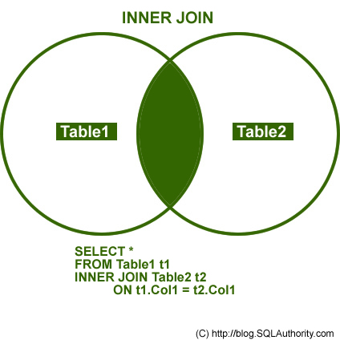

OUTER JOIN
There are three different Outer Join methods.
LEFT OUTER JOIN
This join returns all the rows from the left table in conjunction with the matching rows from the right table. If there are no columns matching in the right table, it returns NULL values.
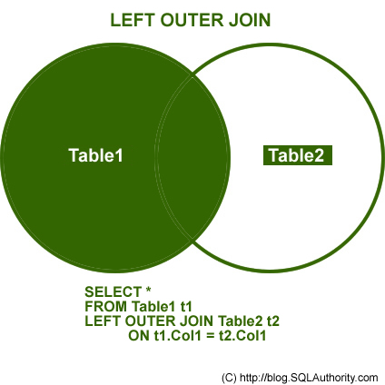

RIGHT OUTER JOIN
This join returns all the rows from the right table in conjunction with the matching rows from the left table. If there are no columns matching in the left table, it returns NULL values.
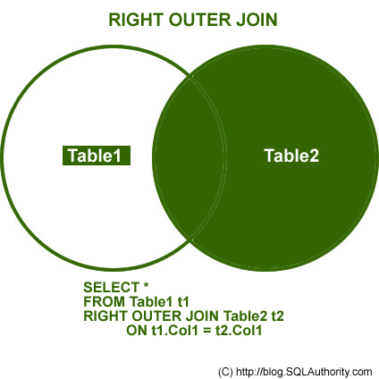

FULL OUTER JOIN
This join combines left outer join and right outer join. It returns row from either table when the conditions are met and returns null value when there is no match.
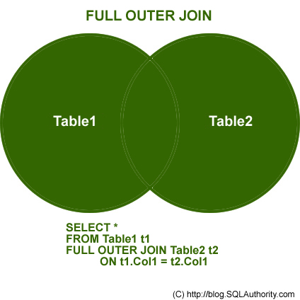

CROSS JOIN
This join is a Cartesian join that does not necessitate any condition to join. The result set contains records that are multiplication of record number from both the tables.
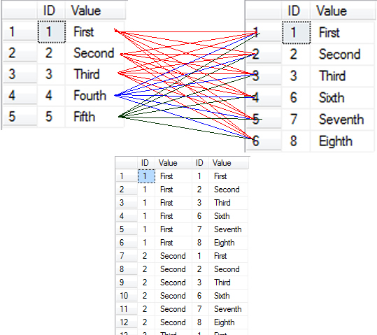

Additional Notes related to JOIN:
The following are three classic examples to display where Outer Join is useful. You will notice several instances where developers write query as given below.
SELECT t1.*
FROM Table1 t1
WHERE t1.ID NOT IN (SELECT t2.ID FROM Table2 t2)
GO
The query demonstrated above can be easily replaced by Outer Join. Indeed, replacing it by Outer Join is the best practice. The query that gives same result as above is displayed here using Outer Join and WHERE clause in join.

/* LEFT JOIN - WHERE NULL */
SELECT t1.*,t2.*
FROM Table1 t1
LEFT JOIN Table2 t2 ON t1.ID = t2.ID
WHERE t2.ID IS NULL
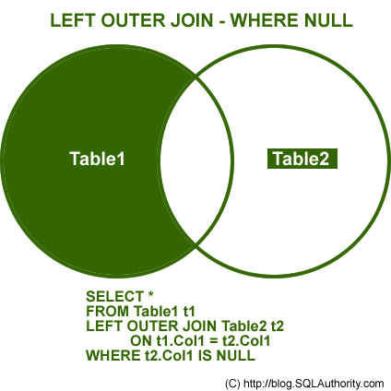
The above example can also be created using Right Outer Join.
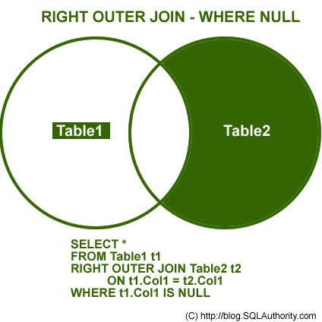
NOT INNER JOIN
Remember, the term Not Inner Join does not exist in database terminology. However, when full Outer Join is used along with WHERE condition, as explained in the above two examples, it will give you exclusive result to Inner Join. This join will give all the results that were not present in Inner Join.
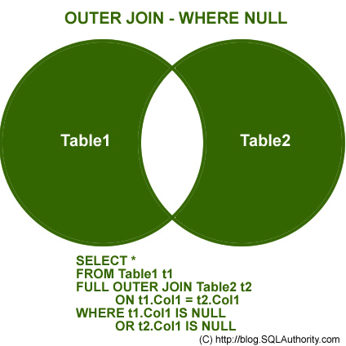
You can download the complete SQL Script here, but for the sake of complicity I am including the same script here.

USE AdventureWorks
GO
CREATE TABLE table1
(ID INT, Value VARCHAR(10))
INSERT INTO Table1 (ID, Value)
SELECT 1,'First'
UNION ALL
SELECT 2,'Second'
UNION ALL
SELECT 3,'Third'
UNION ALL
SELECT 4,'Fourth'
UNION ALL
SELECT 5,'Fifth'
GO
CREATE TABLE table2
(ID INT, Value VARCHAR(10))
INSERT INTO Table2 (ID, Value)
SELECT 1,'First'
UNION ALL
SELECT 2,'Second'
UNION ALL
SELECT 3,'Third'
UNION ALL
SELECT 6,'Sixth'
UNION ALL
SELECT 7,'Seventh'
UNION ALL
SELECT 8,'Eighth'
GO
SELECT *
FROM Table1
SELECT *
FROM Table2
GO
USE AdventureWorks
GO
/* INNER JOIN */
SELECT t1.*,t2.*
FROM Table1 t1
INNER JOIN Table2 t2 ON t1.ID = t2.ID
GO
/* LEFT JOIN */
SELECT t1.*,t2.*
FROM Table1 t1
LEFT JOIN Table2 t2 ON t1.ID = t2.ID
GO
/* RIGHT JOIN */
SELECT t1.*,t2.*
FROM Table1 t1
RIGHT JOIN Table2 t2 ON t1.ID = t2.ID
GO
/* OUTER JOIN */
SELECT t1.*,t2.*
FROM Table1 t1
FULL OUTER JOIN Table2 t2 ON t1.ID = t2.ID
GO
/* LEFT JOIN - WHERE NULL */
SELECT t1.*,t2.*
FROM Table1 t1
LEFT JOIN Table2 t2 ON t1.ID = t2.ID
WHERE t2.ID IS NULL
GO
/* RIGHT JOIN - WHERE NULL */
SELECT t1.*,t2.*
FROM Table1 t1
RIGHT JOIN Table2 t2 ON t1.ID = t2.ID
WHERE t1.ID IS NULL
GO
/* OUTER JOIN - WHERE NULL */
SELECT t1.*,t2.*
FROM Table1 t1
FULL OUTER JOIN Table2 t2 ON t1.ID = t2.ID
WHERE t1.ID IS NULL OR t2.ID IS NULL
GO
/* CROSS JOIN */
SELECT t1.*,t2.*
FROM Table1 t1
CROSS JOIN Table2 t2
GO
DROP TABLE table1
DROP TABLE table2
GO

USE master
GO

IF EXISTS(SELECT name FROM sys.databases WHERE name = N'JoinExample')
DROP DATABASE JoinExample;
GO

CREATE DATABASE JoinExample;
GO

USE JoinExample
GO

IF OBJECT_ID('Table1', 'U') IS NOT NULL
DROP TABLE Table1
GO

CREATE TABLE Table1
(ID INT, Value VARCHAR(10))
INSERT INTO Table1 (ID, Value)
SELECT 1,'First'
UNION ALL
SELECT 2,'Second'
UNION ALL
SELECT 3,'Third'
UNION ALL
SELECT 4,'Fourth'
UNION ALL
SELECT 5,'Fifth'
GO

USE JoinExample
GO

IF OBJECT_ID('Table2', 'U') IS NOT NULL
DROP TABLE Table2
GO

CREATE TABLE Table2
(ID INT, Value VARCHAR(10))
INSERT INTO Table2 (ID, Value)
SELECT 1,'I'
UNION ALL
SELECT 2,'II'
UNION ALL
SELECT 3,'III'
UNION ALL
SELECT 6,'VI'
UNION ALL
SELECT 7,'VII'
UNION ALL
SELECT 8,'VIII'
GO

SELECT * FROM Table1;
SELECT * FROM Table2;
GO

/* 1. INNER JOIN */
SELECT t1.*,t2.*
FROM Table1 t1
INNER JOIN Table2 t2 ON t1.ID = t2.ID
GO

/* 2. LEFT JOIN */
SELECT t1.*,t2.*
FROM Table1 t1
LEFT JOIN Table2 t2 ON t1.ID = t2.ID
GO

/* 3. RIGHT JOIN */
SELECT t1.*,t2.*
FROM Table1 t1
RIGHT JOIN Table2 t2 ON t1.ID = t2.ID
GO

/* 4. OUTER JOIN */
SELECT t1.*,t2.*
FROM Table1 t1
FULL OUTER JOIN Table2 t2 ON t1.ID = t2.ID
GO

/* 5. LEFT JOIN - WHERE NULL */
SELECT t1.*,t2.*
FROM Table1 t1
LEFT JOIN Table2 t2 ON t1.ID = t2.ID
WHERE t2.ID IS NULL
GO

/* 6. RIGHT JOIN - WHERE NULL */
SELECT t1.*,t2.*
FROM Table1 t1
RIGHT JOIN Table2 t2 ON t1.ID = t2.ID
WHERE t1.ID IS NULL
GO

/* 7. OUTER JOIN - WHERE NULL */
SELECT t1.*,t2.*
FROM Table1 t1
FULL OUTER JOIN Table2 t2 ON t1.ID = t2.ID
WHERE t1.ID IS NULL OR t2.ID IS NULL
GO

/* 8. CROSS JOIN */
SELECT t1.*,t2.*
FROM Table1 t1
CROSS JOIN Table2 t2
GO

Self Join
If there are three kinds of joins, i.e. - Inner Join, Outer Join and Cross Join; what type of join is Self Join? In fact, it can be classified under any type of join.
Let us create a new example today, where we will see how Self Join can be implemented as an Inner Join as well as Outer Join.
Let us first create the same table for an employee. One of the columns in the same table contains the ID of manger, who is also an employee for the same company. This way, all the employees and their managers are present in the same table. If we want to find the manager of a particular employee, we need use self join.
USE [master];
Go

--IF EXISTS(SELECT name FROM sys.databases WHERE name = N'Testdb')
--DROP DATABASE [Testdb];
--GO
-- OR

IF DB_ID (N'Testdb') IS NOT NULL
DROP DATABASE [Testdb];
GO

CREATE DATABASE [Testdb];
GO

USE [Testdb];
GO

--IF EXISTS(SELECT name FROM sys.tables WHERE name = N'Test')
--DROP TABLE [Employee];
--GO
-- OR

IF OBJECT_ID (N'Employee', N'U') IS NOT NULL
DROP TABLE [Employee];
GO

-- Create a Table
CREATE TABLE Employee
(
EmployeeID INT PRIMARY KEY,
Name NVARCHAR(50),
ManagerID INT
)
GO

-- Insert Sample Data
INSERT INTO Employee
SELECT 1, 'Mike', 3
UNION ALL
SELECT 2, 'David', 3
UNION ALL
SELECT 3, 'Roger', NULL
UNION ALL
SELECT 4, 'Marry',2
UNION ALL
SELECT 5, 'Joseph',2;
GO

/* Inner and Outer Join as Self Join */
IF OBJECT_ID('Employee', 'U') IS NOT NULL
DROP TABLE Employee
GO

-- Create a Table
CREATE TABLE Employee
(
EmployeeID INT PRIMARY KEY,
Name NVARCHAR(50),
ManagerID INT
)
GO

-- Insert Sample Data
INSERT INTO Employee
SELECT 1, 'Mike', 3
UNION ALL
SELECT 2, 'David', 3
UNION ALL
SELECT 3, 'Roger', NULL
UNION ALL
SELECT 4, 'Marry',2
UNION ALL
SELECT 5, 'Joseph',2;
GO

-- Check the data
SELECT * FROM Employee;
GO

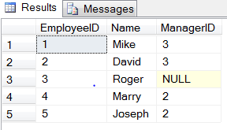

-- Inner Join as Self Join
SELECT E1.Name AS EmployeeName, E2.Name AS ManagerName
FROM Employee E1
INNER JOIN Employee E2
ON E1.ManagerID = E2.EmployeeID;
GO

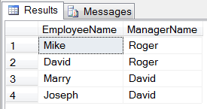

-- Outer Join as Self Join
SELECT E1.Name AS EmployeeName, E2.name AS ManagerName
FROM Employee E1
LEFT JOIN Employee E2
ON E1.ManagerID = E2.EmployeeID;
GO

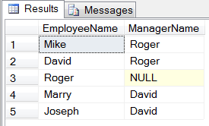

-- Outer Join as Self Join
SELECT E1.Name AS EmployeeName, ISNULL(E2.name, 'Top Manager') AS ManagerName
FROM Employee E1
LEFT JOIN Employee E2
ON E1.ManagerID = E2.EmployeeID;
GO
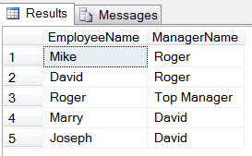
Once we convert Inner Join to Outer Join, we can see the Top Manager as well. Here we have seen how Self Join can behave as an inner join as well as an outer join.
http://blog.sqlauthority.com/2009/04/13/sql-server-introduction-to-joins-basic-of-joins/
http://blog.sqlauthority.com/2010/07/08/sql-server-the-self-join-inner-join-and-outer-join/

